LAB Week 4

Name: Donald McLaughlin

INPUT:

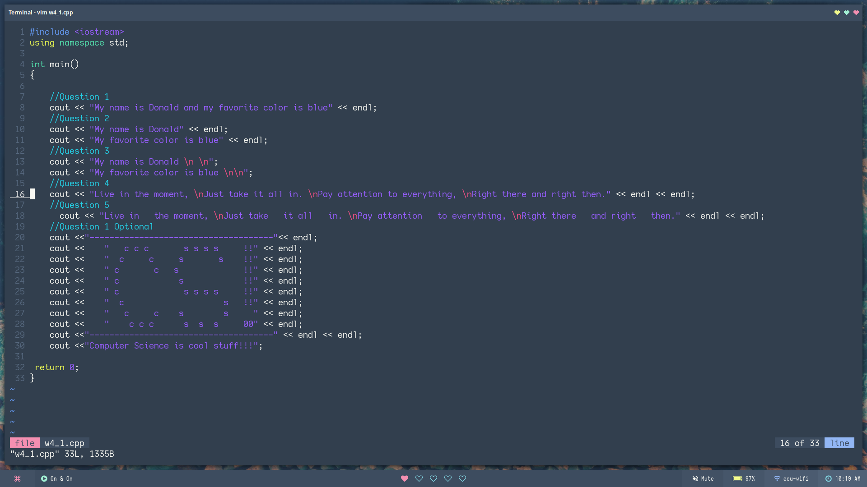
OUTPUT:

